




Writing To and Reading From a File

Introduction to Files (130)

So far we have learned how to receive inputs from users using cout and cin statements. Learning how to write data to and read data from a file is a useful skill that means you do not have to depend on a user to enter data every time you want a program to run and you can save the results.

To write to or read from a file, you must include another type of header (#include <fstream>), define a “file stream object” to which to write, open the file, use the file, and close the file after using it.

/* This program writes to a file, in this case, called prices.txt. */

#include <iostream>
#include <fstream> // handles file streaming input/output
using namespace std;

int main()
{
ofstream outputFile; // define an output file stream
outputFile.open(“prices.txt”); // opens the file to output to it

// a way to write both statements is ofstream outputFile(“prices.txt”);

cout << “Write tree prices to a file.\n”;
outputFile << “Category 1: ” << 39.00 << “\n”;
outputFile << “Category 2: ” << 69.00 << “\n”;
outputFile << “Category 3: ” << 99.00 << “\n”;
outputFile << “Category 4: ” << 199.00 << “\n”;

outputFile.close();
cout << “Done.\n”;

return 0;
}

The output looks like this:

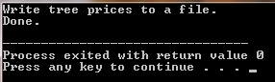
Files written to the project (“WriteToFile1”) folder look like this:

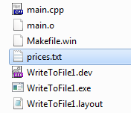

Notice the new prices.txt file you created to hold the data and the new Makefile.win file.

Here is a program that will read the data from the prices.txt file you created:

/* This program reads from a file, in this case the prices.txt file. */

#include <iostream>
#include <iomanip>
#include <string>
#include <fstream> // handles file streaming input/output
using namespace std;

int main()
{
ifstream inFile; // defines an input file stream
string treeCategory;
double price;

inFile.open("prices.txt"); // opens the file to input from it

cout << "Reading data from the file.\n";
cout << fixed << showpoint << setprecision(2);

// the statement above formats the value of the output for variable price

inFile >> treeCategory >> price; // reads the first two file values
cout << treeCategory << " " << price << "\n";
inFile >> treeCategory >> price; // reads the next two file values
cout << treeCategory << " " << price << "\n";
inFile >> treeCategory >> price; // reads the next two file values
cout << treeCategory << " " << price << "\n";
inFile >> treeCategory >> price; // reads the next/last two file values
cout << treeCategory << " " << price << "\n";

inFile.close();
cout << "Done.\n";

return 0;
}

Note that if the file is NOT in the same folder, you need to specify its path, such as:
inFile.open(“C:\\otherfolder\\prices.txt”); // define input file path

The output looks like this:

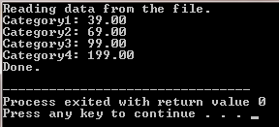

The files created for project ReadFromFile1 are added to the WriteToFile1 project:

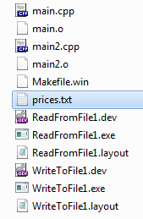

================================================================
SUGGESTED EXERCISES

Use what you have learned above to create programs that will:

- Look back at the tree order program. Write tree order data to a file in a looping program that reads customer orders. Then read the data from the file to create invoices for each customer.

- Make up your own program to write to a file and read from it to perform something of interest or useful. Suggestions are (a) transcript and GPA calculations or (b) drawing something on the screen.

Share these programs with the other students during the next class session.

